Saveetha School of Engineering

Saveetha institute of medical and techinal Sciences department of Information Technology

Computer architecture

COURSE CODE: CSA1282

|  |  |  |  |
| --- | --- | --- | --- |
| s.no | Title | marks | signature |
| 1 | 8 bit addition |  |  |
| 2 | 8 bit substraction |  |  |
| 3 | 8 bit multiplication |  |  |
| 4 | 16 bit addition |  |  |
| 5 | 16 bit substraction |  |  |
| 6 | Single precision format |  |  |
| 7 | Full ladder |  |  |
| 8 | Half ladder |  |  |
| 9 | Integer restoration division |  |  |
| 10 | Booth algorithm |  |  |

PROGRAMS FOR THE COMPUTER ARCHITECTURE

8 BIT ADDITION

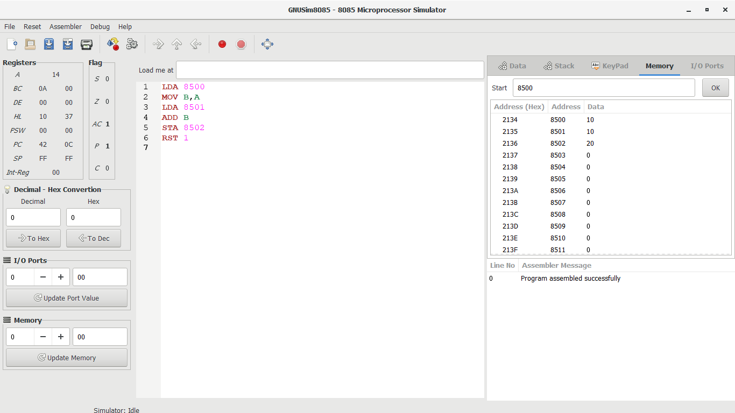

8 BIT SUBSTRACTION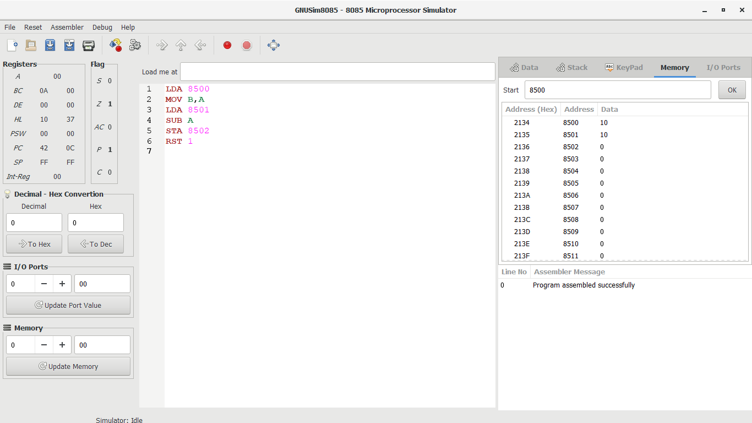

8 BIT MULTIPLICATION

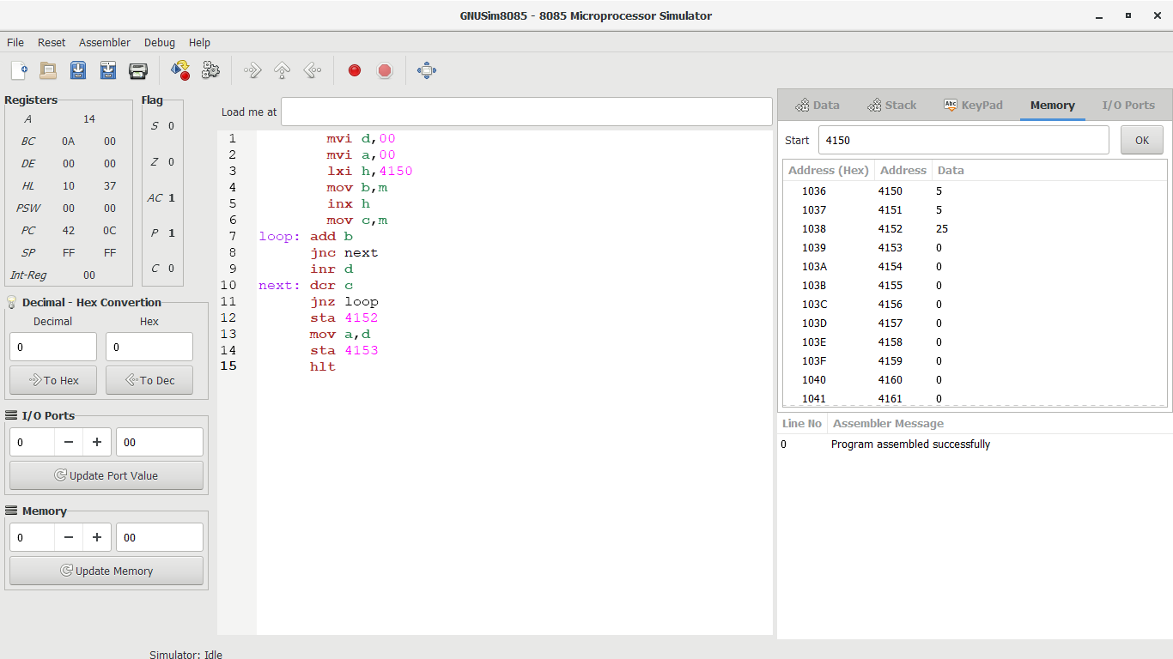

16 bit addition

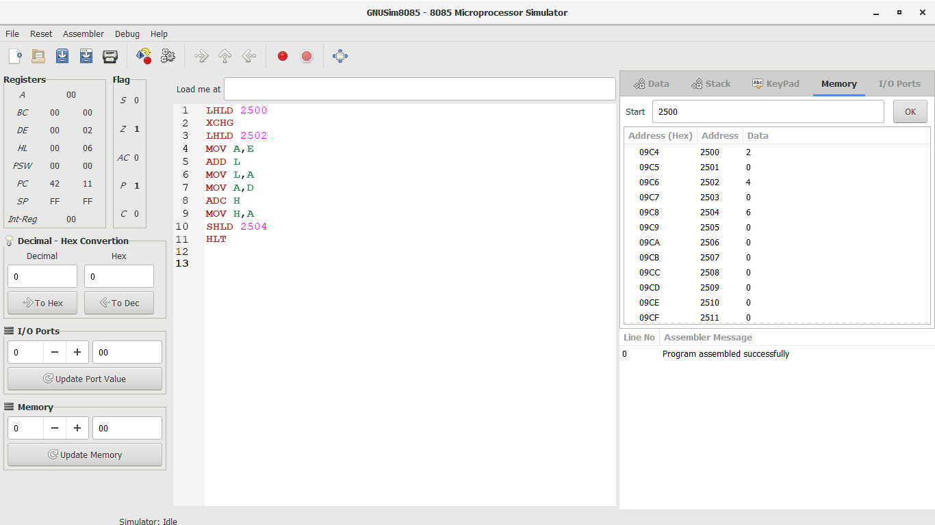

16 BIT SUBTRACTION

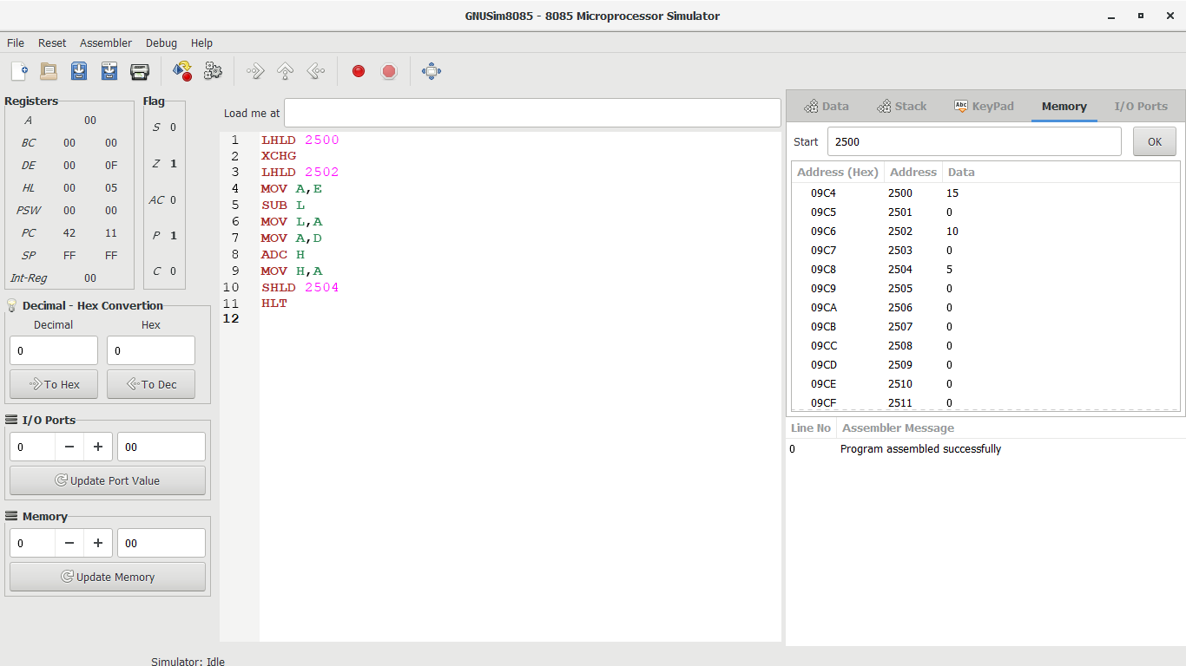

Single precision format

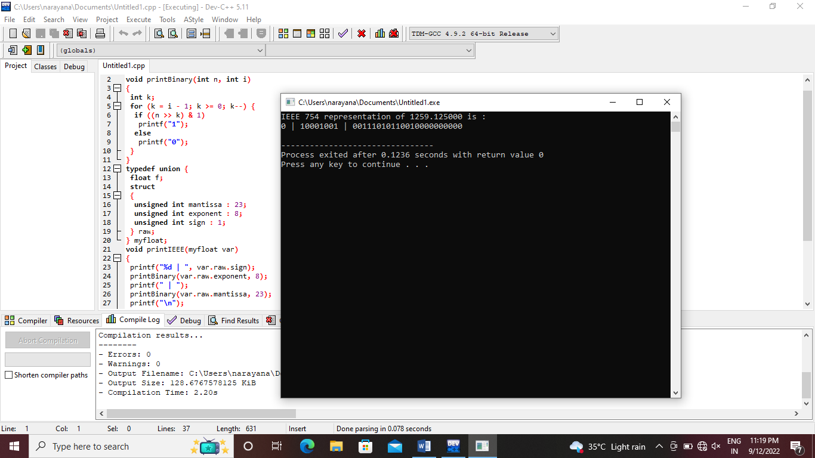

Full ladder

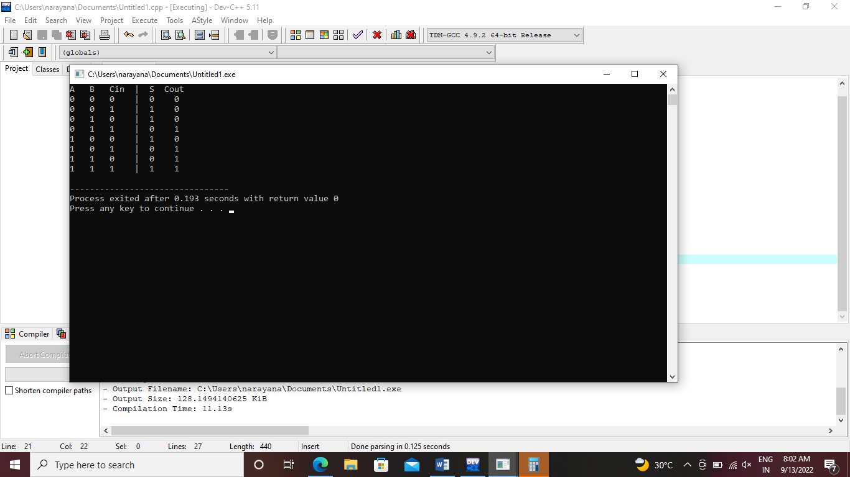

Half ladder

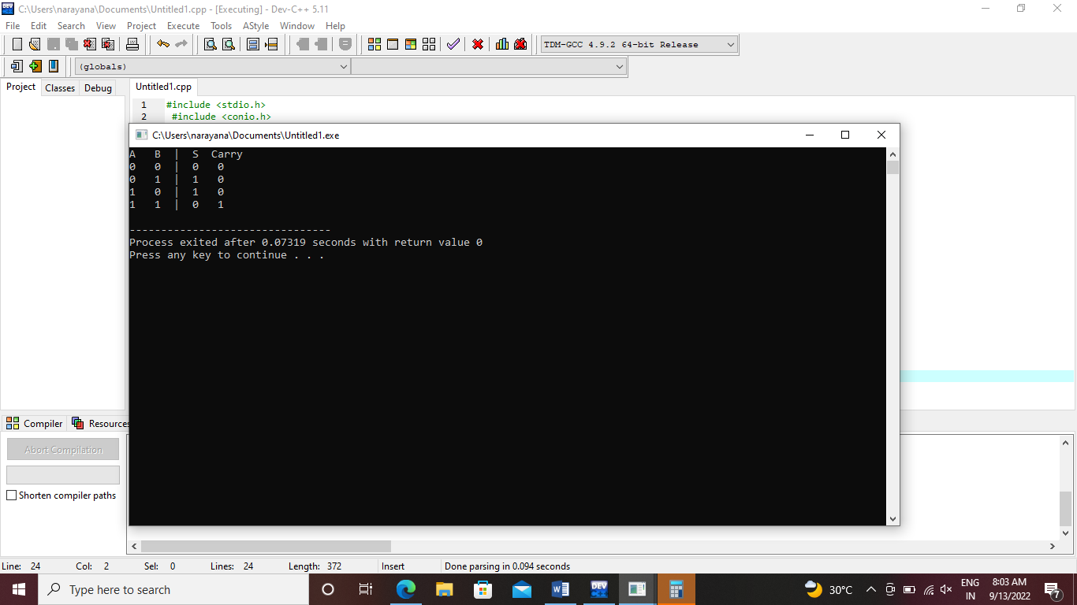

Integer restoration division

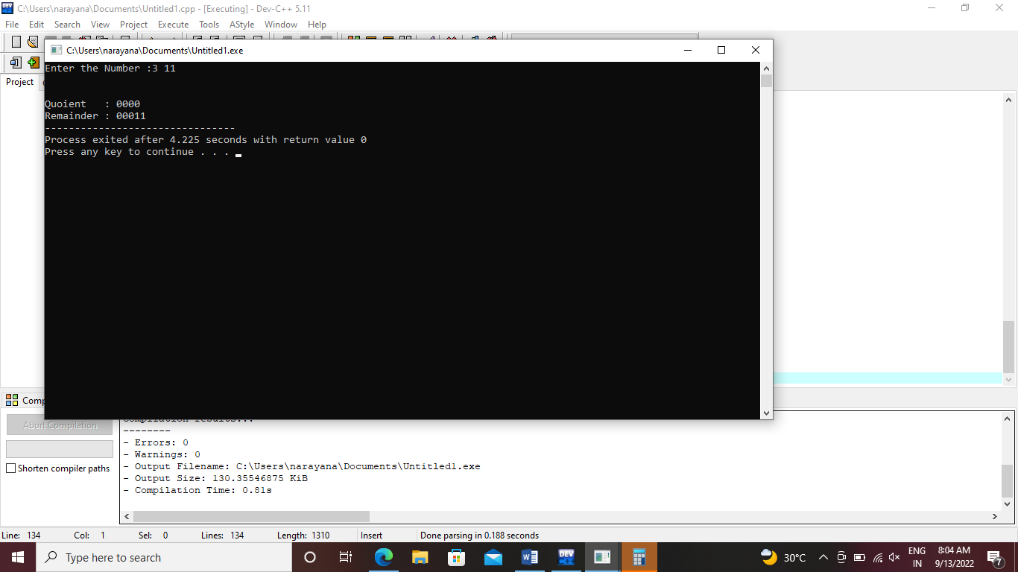

Booth algorithm

